Our Covenant
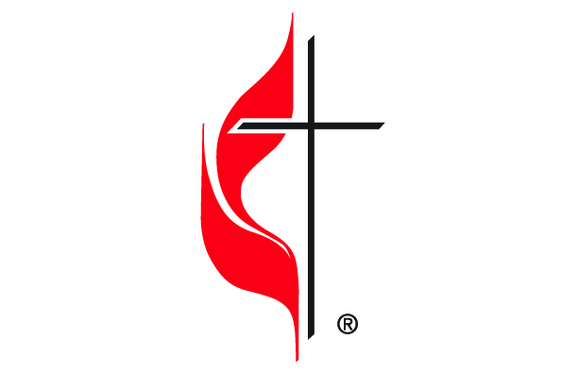
The People of _____________ UMC / UMF
Theological Foundation:
Care for the Other: The people of God have been called by Christ to share in a deep abiding love for one another, demonstrated in a commitment to love like Jesus, act for justice, and remain united in hope.
Our Covenant Relationship: It has long been the history of God’s people to enter into a covenant with God and with one another. A covenant is more than a normal agreement. It is a chosen way of living together in which the people involved freely and voluntarily make binding promises to one another.
COVID-19 Reality: We are well aware of the fact that the novel coronavirus, COVID-19, has been declared a worldwide pandemic by the World Health Organization. COVID-19 is extremely contagious and is believed to spread mainly from person-to-person contact. This reality is what calls us to enter into this covenant at this time.
Our Church Covenant: We are people who care for one another, and we care for the stranger among us. In love and faith, and with God’s help, we commit to one another to protect each other’s health and safety as we seek to prevent the spread of COVID-19. In the spirit of John Wesley’s proclamation of “Do no harm, do good and stay in love with God,” we covenant to the following actions:
Do No Harm
- In accordance with Romans 13, I/we will abide by the directives of the Bishop of the Desert Southwest Conference and his guidance on the extent and ability to open our church campuses and offer in-person gatherings for activities.
- With care for the vulnerable among us, I/we will refrain from attending any activities on the church campus if I am/we are sick with any of the common COVID-19 symptoms, believe I/we have been exposed to someone who is sick, or have attended another activity of 50 or more people in an enclosed setting over the last two weeks.
- Because of the love I/we have for others, within two weeks after attending an activity on the church campus, if I/we test positive for COVID-19, I/we will let church office know of a diagnosis. I/we also understand that the church may keep our identity confidential.
- Considering the health needs of others as being important, I/we commit to wear a face covering at all church gatherings to protect the health of our siblings in Christ.
Do Good
- Knowing that there are those people who are unaware they have an active case of COVID-19, in humility I/we pledge to maintain a minimum distance of 6 from other members. This means that as an act of love I/we will not hug, shake hands, or engage in direct physical contact when I am/we are with others in the church or at church-sponsored activities. I/we will find other ways to greet one another with joy.
- Because of my/our commitment to care for others, I/we agree to use good preventive measures, especially the wearing face coverings, in addition to other measures, to prevent the spread of the virus through touching common surfaces.
- As an act of grace toward others, when in-person worship resumes, I/we agree to be seated by in a designated safe distance seat, even if it is not my ‘regular’ seat at church. I/we further covenant not to ask for special treatment or seating accommodations unless physical needs require it.

- In every effort to care for others, when in-person worship resumes, I/we affirm the need to inform any guests I/we bring to church about our covenant and seek to secure their cooperation in abiding by the covenant.
Stay in Love with God
- Because I/we believe God is with me/us always, I/we seek to honor my/our faith commitment to God and to the church by continuing to give as I/we can and increase giving, if possible, to make sure extra expenses due to cleaning/sanitizing church facilities are covered. I/we do this also because of an awareness that during COVID-19 some in our community of faith have lost jobs and are struggling financially. Continued giving is an act of love and grace for those who can no longer do so.
- In living the principles found in scripture, I/we commit to be patient and gracious with each other as we all seek to address the COVID-19 health and safety challenges and the changing information about the spread and nature of the coronavirus.
Acknowledgement and Waiver
Grounded in the love of God, I/we acknowledge that the instruction from scripture is that we, as covenant people, deal with disagreements and concerns in grace-filled ways, and, therefore, agree that we accept responsibility for our own choices, and the risk that goes along with them. I/we waive any claim against the church in the event that I/we or my/our children, if any, contract COVID-19.
Date: ________________________ .
Signed:
Printed Name:
Signed:
Printed Name:

Philippians 4:5-7 NRSV
Let your gentleness be known to everyone. The Lord is near. Do not worry about anything, but in everything by prayer and supplication with thanksgiving let your requests be made known to God. And the peace of God, which surpasses all understanding, will guard your hearts and your minds in Christ Jesus.

