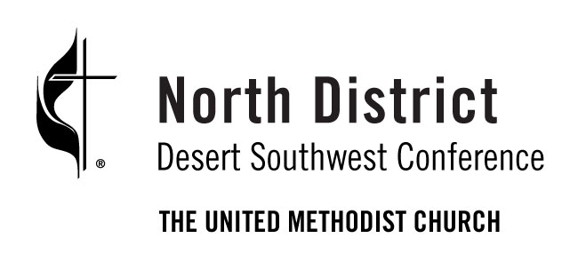
Cultural Competency
Training
December 10, 9:00 AM -12:30 PM (PST)

Green Valley UMC
2200 Robindale Rd, Henderson, NV

This event will nurture and cultivate a biblical and theological understanding of inclusion. Greater awareness equips people to appreciate and seek diversity, enhancing the connection between churches and their communities. Increased cultural competency in our leaders and congregation makes the fulfillment of the Great Commission possible.

The training is much less confrontational than you might imagine. Many participants walk away yearning to learn more about other cultures and how different people live.

Contact: Stephen Govett, revgovett@gmail.com
Register: https://rb.gy/r0aw2o

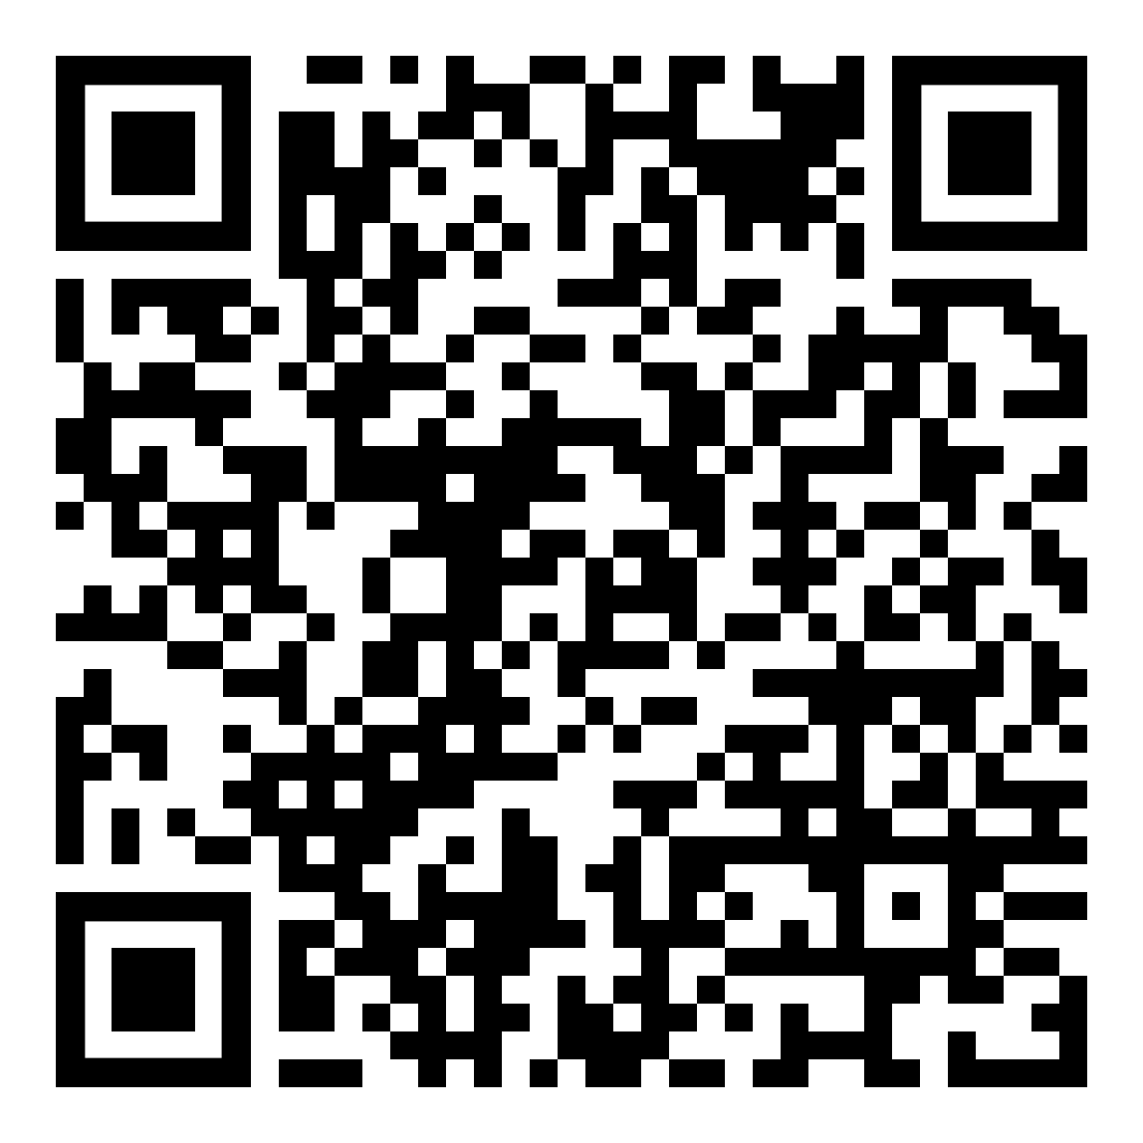

Cultural Competency
Training
December 10, 9:00 AM -12:30 PM (PST)

Green Valley UMC
2200 Robindale Rd, Henderson, NV

This event will nurture and cultivate a biblical and theological understanding of inclusion. Greater awareness equips people to appreciate and seek diversity, enhancing the connection between churches and their communities. Increased cultural competency in our leaders and congregation makes the fulfillment of the Great Commission possible.

The training is much less confrontational than you might imagine. Many participants walk away yearning to learn more about other cultures and how different people live.

Contact: Stephen Govett, revgovett@gmail.com
Register: https://rb.gy/r0aw2o

